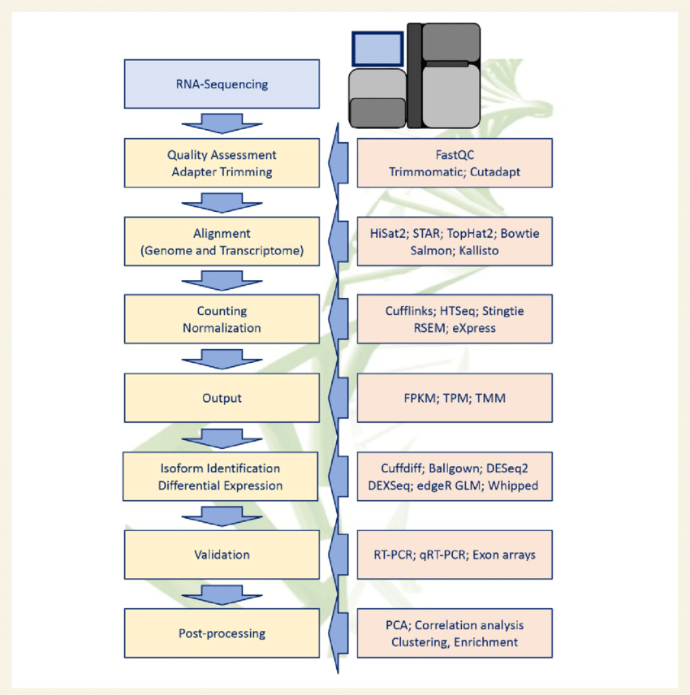
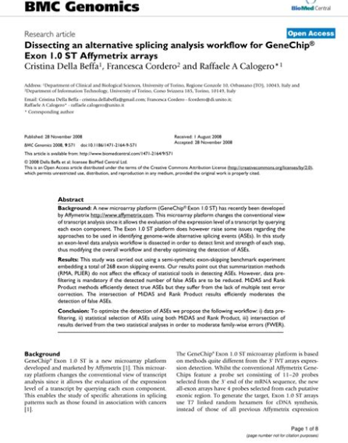
#after preprocessing RNA-Seq data, people often do DESeq2 analysis to identify differentially expressed genes. But DESeq2 is not used for alternative splicing, because it works at the gene level, not the exon or transcript level, which is where alternative splicing happens.
#You do not need to do DESeq2 before doing alternative splicing analysis. The two are independent analyses, but you can combine them later for deeper biological insight.

✅ RNA-Seq Analysis Workflow With Alternative Splicing

Step | Description | Tool(s)
1. QC + Trimming | Check and clean raw reads | FastQC, Trim Galore
2. Alignment | Align reads to genome with splice-aware aligner | STAR, HISAT2
3. Transcript Assembly (optional) | Reconstruct full transcripts | StringTie, Scallop
4. Gene-level DE Analysis | Identify differentially expressed genes | DESeq2, edgeR
5. ➡️ Alternative Splicing Analysis | Identify changes in exon usage / splicing patterns | rMATS, MAJIQ, SUPPA2, DEXSeq
6. Functional Interpretation | Analyze affected pathways, protein isoforms | GO, KEGG, AlphaFold
7. Visualization | View splicing events | IGV, Sashimi plots

🎯 Tools for Step 5 (Alternative Splicing Analysis):

🔹 rMATS – Most popular tool for identifying differential splicing events like:
- Skipped exons (SE)
- Alternative 5’ and 3’ splice sites (A5SS, A3SS)
- Retained introns (RI)
- Mutually exclusive exons (MXE)
Input: BAM files + GTF + group labels
Output: Tables of significant splicing events with p-values and ΔPSI

🔹 SUPPA2 – Quantifies splicing using transcript abundances (from Kallisto or Salmon)
Input: Transcript-level quant (TPM) + event annotation
Output: PSI values and differential splicing stats

🔹 DEXSeq – Exon-level analysis
Input: Count matrix from exon counting tools (e.g., featureCounts)
Use case: Fine-grained analysis of exon usage

📌 So to summarize:
- DESeq2 = changes in total gene expression
- rMATS / SUPPA2 / DEXSeq = changes in splicing/exon usage/transcript isoforms
You usually run these in parallel:
- One pipeline for DEGs (with DESeq2)
- One for differential splicing (with rMATS or others)
—-

Here's how it works conceptually:

✅ DESeq2 (Gene-level Differential Expression):
- Tells you how much the entire gene's expression changes between conditions (e.g., tumor vs. normal).
- Example output: Gene X is 4-fold upregulated in cancer.

✅ Alternative Splicing (Exon or Isoform Level):
- Tells you whether different splice variants of the gene are used in different conditions—even if the overall gene expression doesn’t change!
- Example output: Gene X has an exon that is skipped in cancer but included in normal.

🎯 Key Insight:
A gene may not be differentially expressed at the total level (so DESeq2 won’t catch it), but it may be differentially spliced—which could drastically change its function.

🧪 Best Practice:
Run both analyses independently:
- 🔹 Run DESeq2 for gene-level expression differences.
- 🔹 Run rMATS/SUPPA2/DEXSeq for splicing-level changes.
Then, combine them like this:
- See if any differentially spliced genes are also differentially expressed.
- Prioritize splicing events in genes that are up/downregulated AND altered in splicing—they might be functionally significant in cancer.

📊 Example Table (combined analysis):

Gene | Fold Change (DESeq2) | Splicing Event | ΔPSI | Significance
TP53 | +3.5 (up) | Exon skipping | -25% | p = 0.01
BCL2 | ~0 (no change) | Alt 3’ splice | +40% | p = 0.001
MDM2 | -2.2 (down) | Intron retention | +15% | p = 0.03

So no, you don't need to do DESeq2 first, but it helps to run both and integrate the results later.

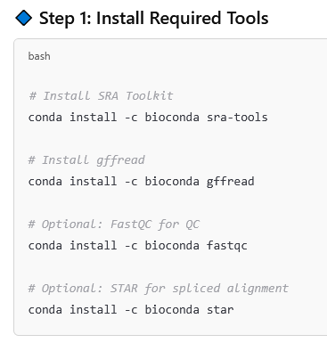
check if the SRA Toolkit is installed
fastq-dump --version
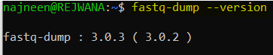

conda install -c bioconda gffread
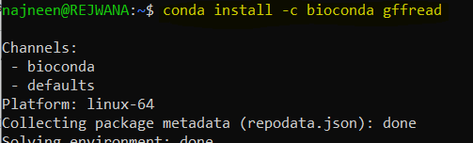

conda install -c bioconda fastqc
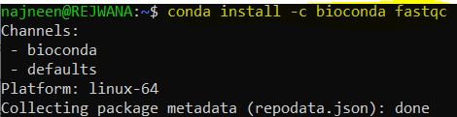

fastqc
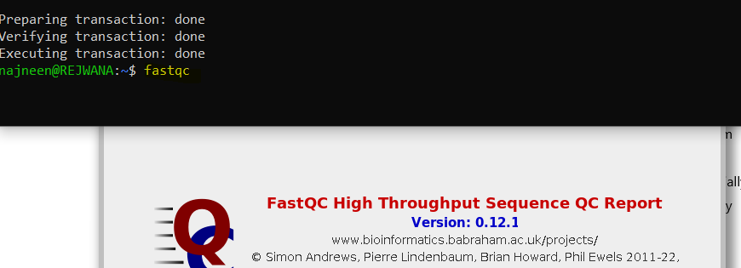

conda install -c bioconda star
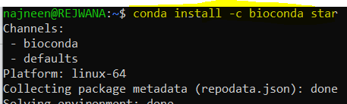

Step 2: Download Annotation (GTF) from GENCODE or Ensembl

✅ GENCODE (human)
wget https://ftp.ebi.ac.uk/pub/databases/gencode/Gencode_human/release_44/gencode.v44.annotation.gtf.gz
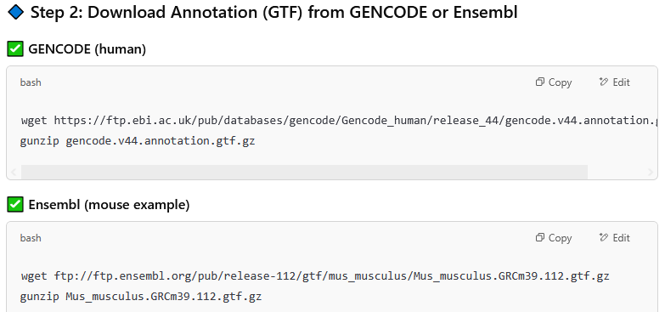
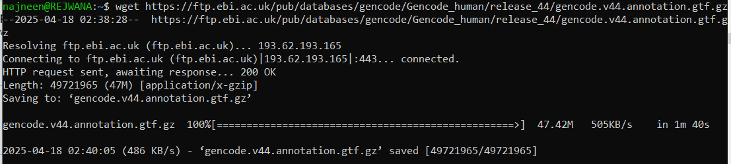

ls

gunzip gencode.v44.annotation.gtf.gz
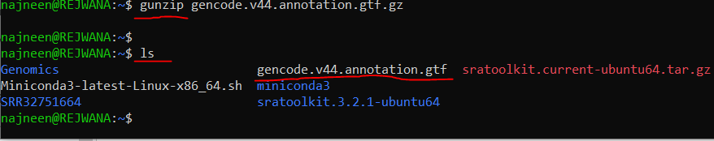

Step 3: Get Transcript Sequences (FASTA)
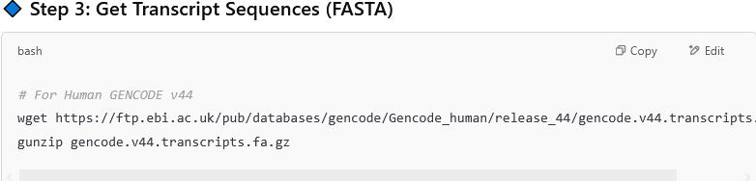
# For Human GENCODE v44
wget https://ftp.ebi.ac.uk/pub/databases/gencode/Gencode_human/release_44/gencode.v44.transcripts.fa.gz

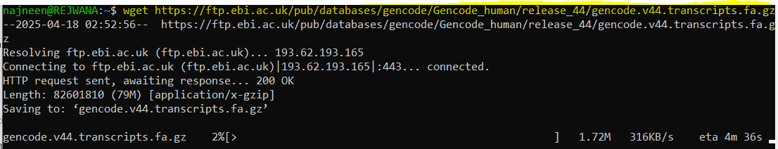
gunzip gencode.v44.transcripts.fa.gz

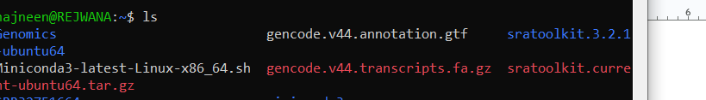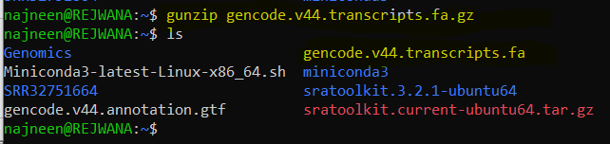

Step 4: Download RNA-Seq Sample from SRA (with ID)

# Prefetch the data
prefetch SRR12345678

# Convert to FASTQ
fasterq-dump SRR12345678

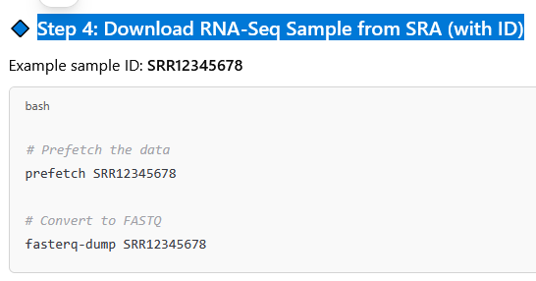
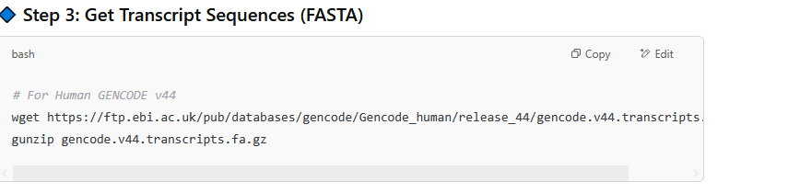
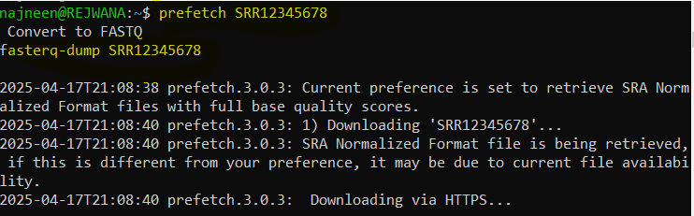

STAR Command for Paired-End Data:
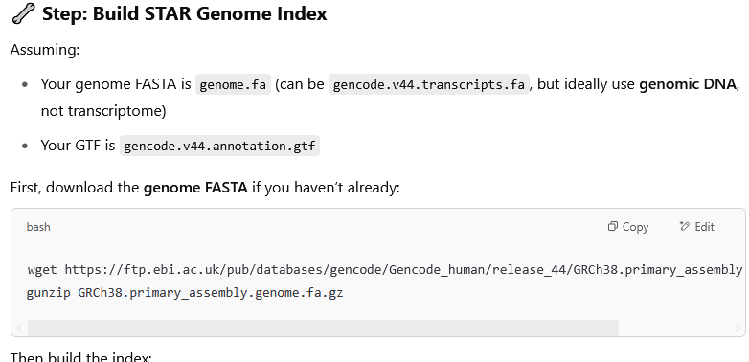
wget https://ftp.ebi.ac.uk/pub/databases/gencode/Gencode_human/release_44/GRCh38.primary_assembly.genome.fa.gz
gunzip GRCh38.primary_assembly.genome.fa.gz

